1 Nancevallon, Higher Brea, Camborne, TR14 9DE
Clerk to the Council, Mrs Karen Harding
clerk@kenwynparishcouncil.gov.uk
Telephone 01209 610250/ 0800 2346077

Kenwyn Parish Council Grass & Grounds Contract

2023 -2026

MAINTENANCE/GRASS CUTTING CONTRACT

Invitation to Tender

Outline

Kenwyn Parish Council (“the Council”) hereby invites tenders for the carrying out of the Maintenance and Grass cutting within our Parish in accordance with the Contract documents attached, which comprise:

Appendices
- Standard Conditions of the Contract
- Specification of Works
- Schedule of Works
- Parish Map
- Formal Tender
- Questionnaire

Tenders

  - Tenders should be submitted for all work set out in the contract by mid-day 31st January 2023, any tenders received after this date will not be considered.

  - Prospective Contractors should ensure that they are completely familiar with the nature and extent of the obligations to be accepted by them, if their tender is accepted.

  - Any queries regarding the interpretation of any part of the Contract Documents should be addressed to the Parish Clerk by no later than one week before the closing date.

  - The tender shall be submitted on the form of Tender attached as Appendix E

  - Prospective Contractors should note that the Councils decision is final and no correspondence will be entered into why the tender has been rejected.

  - The successful tender together with the Councils written acceptance shall form a binding agreement in the terms of the Contract documents.

  - if having examined the tender documents you wish to submit a tender you should

    - Fully complete and return the following documents Appendix E - Form of Tender
Appendix F - Questionnaire

    - Return tenders and all related documentation by mid-day 31st January 2023 to: Kenwyn Parish Clerk

Appendix A - Standard Conditions of the Contract Extent of Works
Generally the work will comprise of the cutting of grass, hedges where specified on land within the Parish of Kenwyn. This will include trimming around play equipment, outside furniture, trees, bushes as itemised within the contract.
The Parish Council expect that all Cuttings are left on site but are swept away from paths, play equipment and walkways to avoid any danger to pedestrians.

Site Details

The sites are situated through Kenwyn Parish and are identified on the plans enclosed under Appendix D.

It is suggested that before tendering the prospective contractor visit and the sites to familiarise and satisfy himself as to the extent of the contract. The Council will not accept any claims from a failure to familiarise himself with the contract.

Works and Equipment

We expect the workmanship to be of the highest standard and shall conform to all relevant British Standards, Specifications and Codes of Practice.

Additional Works

The Council may add assets and additional fixtures through the normal course of business during the contract and unless agreed beforehand by the Council, no application from the Contractor to adjust the Contract price will be considered.

Duration of Contract

The duration of the Contract will be three years and there will be an initial assessment on performance after 6 months in any Contract of more than 12 months. Any decision the Council make on terminating the Contract will be accepted by the Contractor without further consideration. Such a decision will involve a months’ notice either way.

Payment to the Contractor

The Contractor will submit a monthly account, in arrears, detailing the work carried out during that period.

Insurance

The Contractor is required to have Public Liability Insurance to the minimum sum of £5,000,000 and a current Certificate of Insurance. The Contractor will indemnify the Parish Council against any claim or proceedings for injury or damage to any property, persons or animals as a result of negligence, poor workmanship or failure to notify the Council of any action likely to cause injury or damage to a third party. The Contractor is required to also have Employers Liability and Vehicle Insurance.

All Insurance Certificates stated above must be provided to the Parish Clerk prior to the commencement of the Contract.

Health & Safety

The Contractor shall accept all responsibility for compliance with the Health & Safety at Work Act and all other Acts and regulations in respect of work set out in this Contract. A copy of your Health & Safety Policy must be provided to the Parish Clerk prior to the commencement of the Contract.

Notes to Tenderers

- The Form of tender and standard Conditions of the Contract must be read in conjunction with the Specification of works, Plans and Schedule of Works.

Contractors are advised to read all documentation carefully.

- The prices to be included in the Form of Tender are to be the full inclusive value of the work described, including all profit, costs, expenses, travel costs, general risks, liabilities, obligations and VAT.

The Council will not pay towards any travel costs and dispensations if you are outside of the local area.

- No alteration to the Form of Tender is to be made by the Contractor. Any alteration, amendment or note made by the Contractor will not be recognised and the Schedule of Works will be adhered to.

- A regular inspection will be carried out by the Council throughout the period of the Contract to ensure that work is completed in accordance with the Specification of works.

- Invoices presented for payment must include a Schedule of the Works completed including dates and times of work.

- If any clarification is required then the Contractor should contact the Parish Clerk.

- The Form of Tender requires a signature and is intended to allow for an un-biased process, your name and company will be withheld by the Clerk until the voting process has been completed.

- If your tender is successful, you will be asked to submit a Risk Assessment of the activities to be carried out under this Contract and all relevant Insurance documents to the Parish Clerk before the commencement of this Contract.

APPENDIX B

Specification of Works

- Prior to cutting an area, the Contractor will ensure that the area is free of significantly large stones, paper, tins, bottles and other debris.

- The Contractor will also inspect each site for areas of ground sinkage/potholes and areas of potential hazard and will inform the Council immediately of any specific hazards.

- The Contractor will during the period of the Contract, ensure that all machines in grass cutting operations are sharp and set properly to produce a true and even cut. All grass areas will be cut cleanly and evenly and without damage to the existing surfaces. Any damage of areas grass not cut to the approval of the council from a lack of such maintenance will be made good by the Contractor at his own expense.

- The Contractor will during the period of the Contract ensure that machines are properly maintained and guarded so as to present no danger to the operator, surrounding buildings, vehicles or any person or animal in the vicinity of operations. The Contractor and any staff will be expected to be wearing the appropriate safety equipment( Boots, reflective vests, ear defenders and goggles as necessary) at all times they are engaged in work for the Council.

- Any relevant signage should be in place before commencing work.

- The Contractor will during the period of the Contract ensure that any form of growth inhibitor is NOT used to any area of turf without prior sanction from the Council in writing,

- The Contractor will be expected to complete one area at a time before moving on to the next. Immediately after cutting, ensure that all glass clippings and other debris are cleared from all paved areas, playground equipment, safety surfaces, memorial Stones, paths and public footpaths etc. by sweeping or blower.

- The Contractor is expected to cut/mow/strim as close as possible to fixed obstructions. That includes all areas of clover/nettles etc. that fall within large areas of grass. Moveable obstructions should be removed to facilitate cutting and replaced before the Contractor leaves site.

- The Contractor should take care in areas of spring bulbs and avoid them during the growing and flowering season. Cutting of these patches should only commence four weeks after the flowers have died back.

- In very wet conditions, all operations involving grass cutting shall cease until the conditions allow operations to commence without damaging the surface levels or contours of the land.

- Should the Contractor cause damage to the surface levels or contours or create divots during grass cutting then the Contractor will at his own expense repair and re-instate such damage forthwith.

- Cuts shall commence on 1st March and end on 31st October each year and shall be carried out fortnightly between those dates.

- All persons operating cutting machinery must be satisfactorily trained, and the Council reserves the right to ask the Contractor to provide adequate proof that his/her operators are competent, well trained and conversant with Health & Safety legislation.

- If spraying is required as a weed control measure then Certification of the relevant qualifications, COSHH etc. will be provided by the Contractor to the Parish Clerk prior to

spraying works commencing.

- Any incidence of Japanese Knotweed must be reported immediately to the Clerk and any disposal must be done as per the Environmental Agency guidelines. Therefore, the contractor and their staff should be familiar with the identification of most common invasive non-native plants.

APPENDIX C

Schedule of Works

  - All grass areas to be cut fortnightly from 1st March – 31st October each year.

  - The roadside hedge boundary at Shortlanesend Playing Field to be strimmed annually.

  - To include strimming around/under play equipment/benches/tables, memorials and other obstructions

  - All paths, safety surfaces and play areas around the grassed areas to be cleaned by sweeping or with a blower after each cut.

  - All paths to be straight edged and kept weed free.

Kenwyn Parish :

Threemilestone Playing Field, Polstain Road, Threemilestone, Truro, TR3 6DH

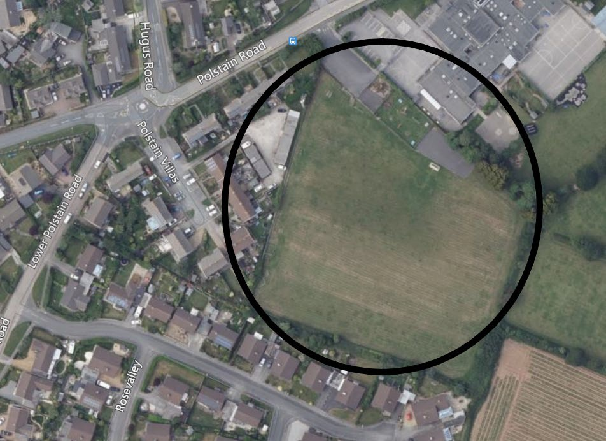
Ariel Photograph of the site

Shortlanesend Playing Field, School Hill, Shortlanesend, Truro, TR4 9DU

Ariel Photograph of the site
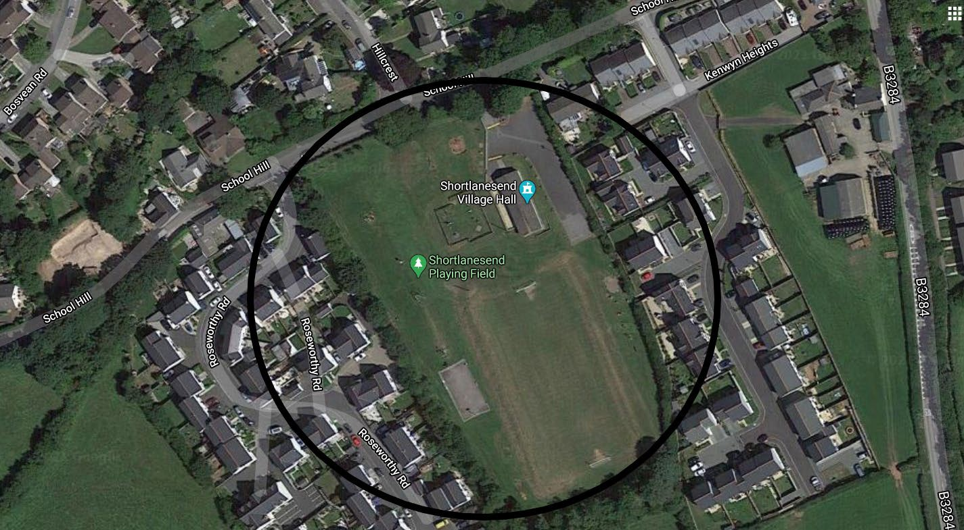

Chyvelah Ope Play Area, Chyvelah Ope, Gloweth, Truro, TR1 3YA

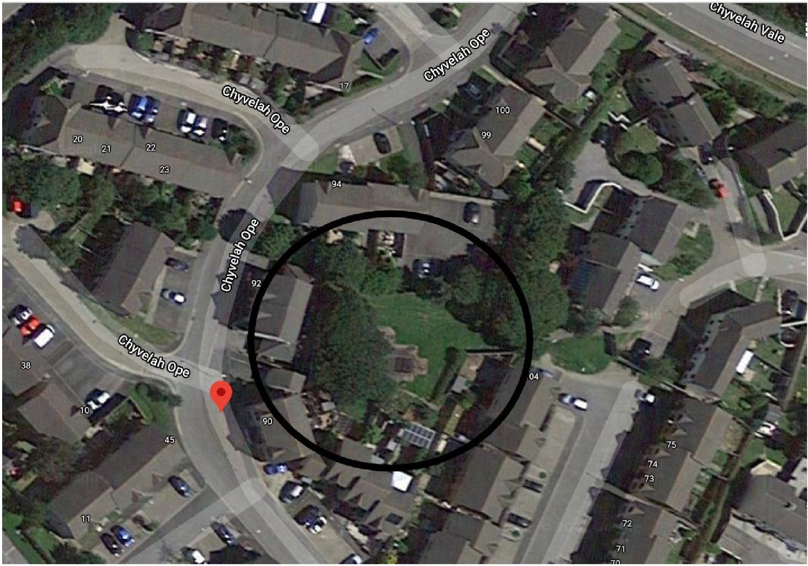
Ariel Photograph of the site

Parish Map

APPENDIX E -Formal Tender

Grass & Grounds Contract (Grass Cutting)

 | 2023/2024 | 2024/2025 | 2025/2026
Itemised areas as required per cut
Net Total
VAT
Total cost of Contract (inc VAT) | £ | £ | £

I/We understand that Kenwyn Parish Council is not bound to accept the lowest or any tender and that the Council will not be responsible for any expense incurred in the preparation of this tender.

I/We agree to complete the work in accordance with the Invitation to Tender, Standard Contract Terms, Specification of Works, Schedule of works as laid out in conjunction with the site plans.

I/We certify that the amount of the Tender has not been calculated by agreement or arrangement with any other person, firm or company and that the amount tendered has not been communicated in any way to any person, firm or company and will not be communicated to any person, firm or company until after the closing date for the submission of Tenders.

I/We accept that if successful in securing the Contract that we will produce the necessary Certificates of Insurance and all other relevant documentation prior to commencement of the Contract.

Signature:

Date:

APPENDIX F- Questionnaire

Name:

Address:

Landline:

Mobile:

Email Address:

Company Name:

Position in Company:

Nature of Business:

VAT Registered ?:

Is this a subsidiary of another company?: Yes No Please give details if Yes:

Date business Formed:
Number of grounds/maintenance staff:

If applicable, state which branch the contract will be serviced from (or any other information that might assist in determining the Suitability/location of your company)

Signed : Dated:

